Ecosystem Services – How Some Wild Animals Protect Human Health

An ecosystem is a community of living organisms (plants, animals, and microorganisms) interacting with each other and their environment.

Ecosystem services are the benefits that humans receive from nature. One example is pollination. Wild bees and other wild animals carry the pollen from the male part of one flower to the female part of another flower. Pollination allows plants to make seeds and fruits around the seeds. Other examples of ecosystem services are described in the figure. | 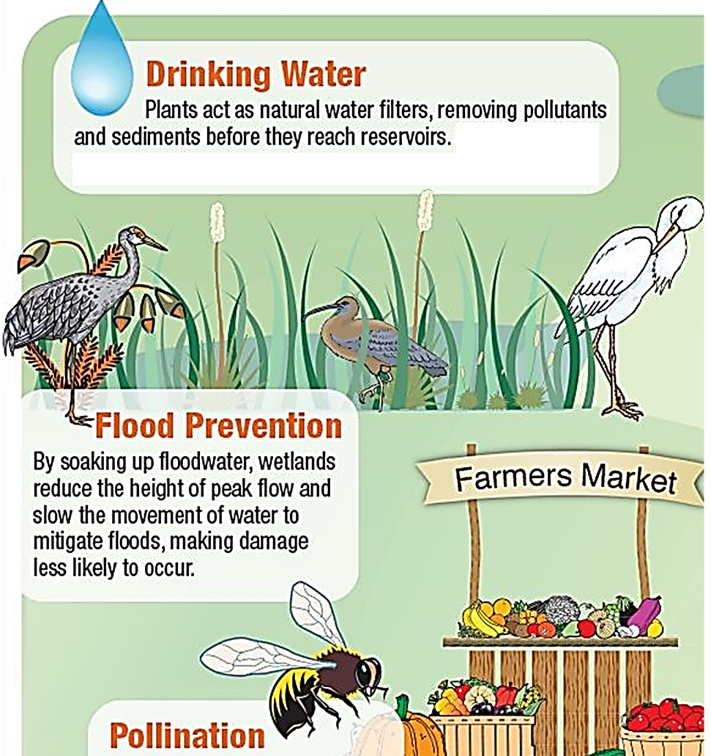

Another ecosystem service is provided by scavengers and decomposers.
- Scavengers (e.g. vultures) eat dead animals and release small molecules.
- Decomposers (e.g. fungi and bacteria) break down organic molecules into smaller molecules.
- These smaller molecules (e.g. CO₂) are nutrients that plants can use to make plant molecules.

1. What ecosystem service for agriculture is provided by scavengers and decomposers?

In the pages that follow, you will analyze two examples of ecosystem services. These examples will demonstrate how some wild animals protect human health.

Watch “Vultures: the acid-puking, plague-busting heroes of the ecosystem” (https://www.youtube.com/watch?v=1WIUuGCIfcc).

2. Why don’t vultures get sick from eating infected dead bodies? | 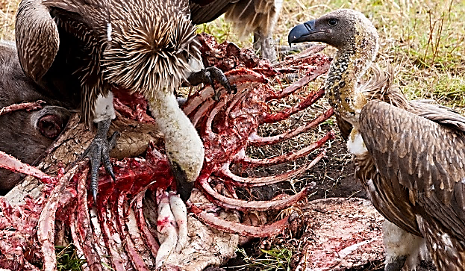

To learn more, watch “How a die-off of vultures cost a country billions” (https://www.youtube.com/watch?v=OwYPzeD3TJc). (I suggest that you slow down this video to make it easier to understand. You can do this by tapping on the gear that appears when you hover over the bottom of the video; then tap on playback speed and set it to 0.8.)

3. What caused the die-off of vultures in India?

4a. When the vulture populations decreased, why did the populations of rats and feral (wild) dogs increase? | 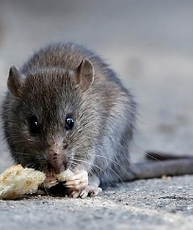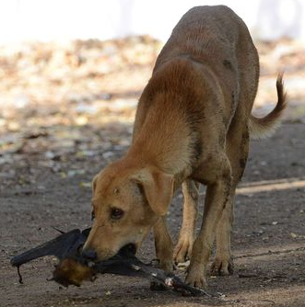

4b. What advantage do vultures have as scavengers, compared to rats and feral dogs?

4c. How did the die-off of vultures cost India billions of dollars?

4d. Suggest a practical approach that could have reduced this problem.

5. Complete this flowchart to show how the decreased number of vultures in India increased human mortality.
Humans used a drug to treat farm animals. This drug was fatal for vultures that ate the carcass of a farm animal that had recently been treated with the drug.

The die-off of vultures is one example of how humans have inadvertently changed ecosystems in ways that have increased human mortality. Next, you will analyze a second example of how a change in ecosystems resulted in increased human mortality. This change was caused when a person accidentally transported a spore of a fungus from Europe to North America.

The fungus is called Pseudogymnoascus destructans (abbreviation = Pd). Pd infects the skin of the wings and nose of hibernating bats. During centuries of exposure, European bats have evolved resistance to the Pd fungus, so European bats rarely get sick when infected with the Pd fungus. In contrast, North American bats were much more likely to die when infected with the Pd fungus. As the Pd fungus spread across North America, it killed millions of bats.

Most bats hunt at night for flying insects, including insects that harm crops. But how do bats find flying insects at night, when there is little or no light?

Bats use sound to find their prey. A flying bat makes sounds; the bat can locate a flying insect based on the echoes that come back from the flying insect. For example, a bat can tell how far away the insect is by how long it takes for the sound to travel to the insect and the echo to travel back.  6. Why is this technique for finding flying insects called “echolocation”? | 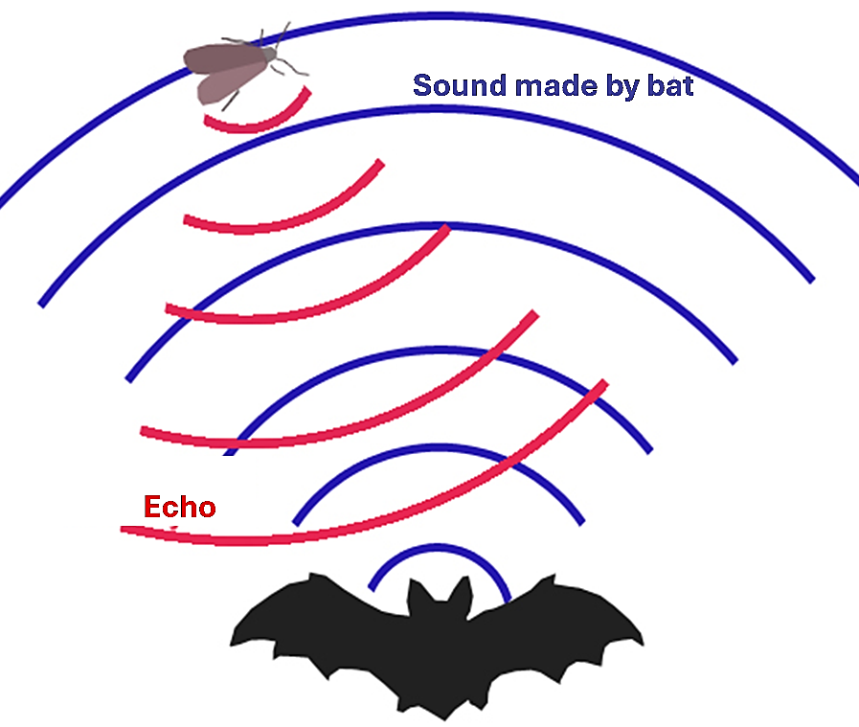
Echolocation is so effective that bats can catch 10-20 insects per minute. After the Pd fungus killed many North American bats, fewer bats ate fewer insects, including fewer agricultural pests.  Farmers responded to the increase in agricultural pest insects by spraying more insecticides. These poisons spread to humans by wind and water. In utero insecticide exposure caused increased infant mortality. |  | 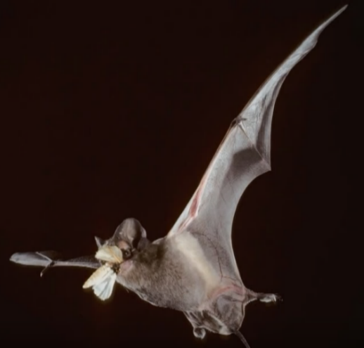

7. Complete this flowchart to show how the spread of the Pd fungus from Europe to North America caused an increase in human infant mortality.

A person accidentally spread the Pd fungus from Europe to North America.

8a. Define ecosystem services.

8b. What ecosystem service do bats provide?

8c. What ecosystem service do vultures provide?

Watch “Stopping White-Nose Syndrome: Can We Save Bats in North America?” (https://www.youtube.com/watch?v=GNPeHhpBAnE). (The disease caused by the Pd fungus is called white-nose syndrome because this fungus is particularly obvious on the noses of bats as they hang upside down during hibernation.)

Optional Question. Read “Preventing and treating white-nose syndrome” (https://www.fws.gov/story/preventing-and-treating-white-nose-syndrome). Evaluate each approach to combating white-nose syndrome for:
- effectiveness in combating white-nose syndrome mortality
- how easy it would be to apply this approach to the many populations of bats.
Based on this information, choose 2-3 approaches that you think would be most helpful to save North American bats from white-nose syndrome. Explain your reasoning. Write your answer on a separate piece of paper or on the back of this page.

By Dr. Ingrid Waldron, Biology Department, University of Pennsylvania, © 2026. This Student Handout, a simpler version, and Teacher Notes (with instructional suggestions and background biology) are available at https://serendipstudio.org/exchange/bioactivities/ecologicaldisturbance.

